**Learning bootstrap**

* **Bootstrap nested rows and columns**

code exemples :

<body>

  <div class="container">

    <div class="row">

      <div class="col-sm-3 col-xs-3">

        <div class="row">

          <div class="col-xs-12">

            <div class="sidebarcontent">Side bar 1</div>

          </div>

        </div>

        <div class="row">

          <div class="col-xs-12">

            <div class="sidebarcontent">Side bar 2</div>

          </div>

        </div>

        <!-- <div class="maincontains">left side bar</div> -->

      </div>

      <div class="col-sm-9 col-xs-9">

        <div class="maincontains"> main content area </div>

      </div>

    </div>

  </div>

* **Bootstrap image galery**
* <body>
* <div class="container">
* <div class="row">
* <div class="col-lg-12">
* <h3>bootsrap image galery</h3>
* </div>
* <div class="col-lg-3 col-md-4 col-sm-6 " >
* <a href="images/cat-mouse.jpg" class="thumbnail">
* <p> chat qui joue avec la souris </p>
* <img src="images/cat-mouse.jpg" class="img-fluid" class="fixed-image">
* </a>
* </div>
* <div class="col-lg-3 col-md-4 col-sm-6 ">
* <a href="images/cat-sleep.webp" class="thumbnail">
* <p> chat qui dors </p>
* <img src="images/cat-sleep.webp" class="img-fluid" class="fixed-image">
* </a>
* </div>
* <div class="col-lg-3 col-md-4 col-sm-6 ">
* <a href="images/font1.jpg" class="thumbnail">
* <p> font2 </p>
* <img src="images/font1.jpg" class="img-fluid" class="fixed-image">
* </a>
* </div>
* <div class="col-lg-3 col-md-4 col-sm-6 ">
* <a href="images/font2.jpg" class="thumbnail">
* <p> font2 </p>
* <img src="images/font2.jpg" class="img-fluid" class="fixed-image">
* </a>
* </div>
* <div class="col-lg-3 col-md-4 col-sm-6 ">
* <a href="images/font3.jpg" class="thumbnail">
* <p> font3 </p>
* <img src="images/font3.jpg" class="img-fluid" class="fixed-image">
* </a>
* </div>
* <div class="col-lg-3 col-md-4 col-sm-6 ">
* <a href="images/font4.jpg" class="thumbnail">
* <p> font4 </p>
* <img src="images/font4.jpg" class="img-fluid" class="fixed-image">
* </a>
* </div>
* </div>
* </div>
* </body>
* 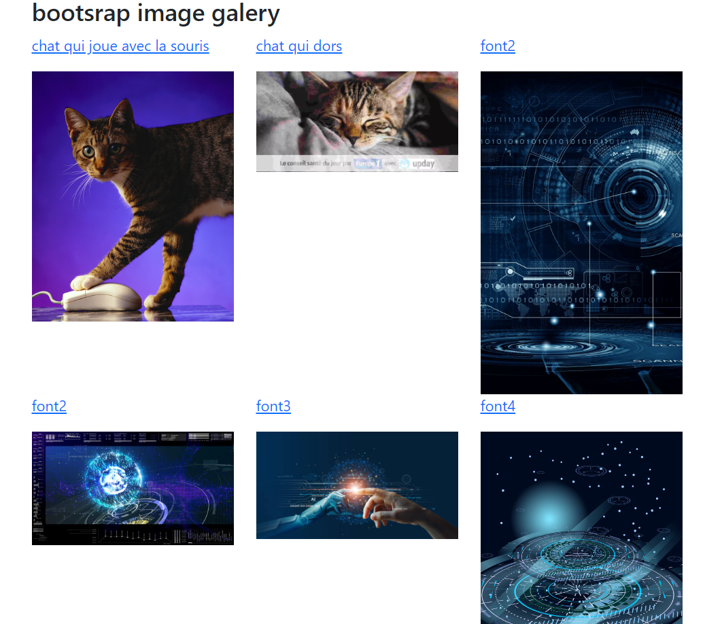

Still searching how to make them how to have the same size